SUPPLEMENTARY MATERIALS
PECULIARITIES OF eGFP GENE EXPRESSION IN TRANSPLASTOMIC TOBACCO PLANTS NICOTIANA TABACUM L. CV. PETIT HAVANA
Yu. V. Sidorchuk^{a,} *, P. A. Belavinª, A. A. Zagorskayaª, T. V. Marenkovaª, V. V. Kuznetsovª, E. S. Khajrulinaª, E. V. Deinekoª
ªInstitute of Cytology and Genetics, Siberian Branch of Russian Academy of Sciences, Novosibirsk, Russia
Corresponding author: Yu. V. Sidorchuk
*e-mail: sidorch@bionet.nsc.ru

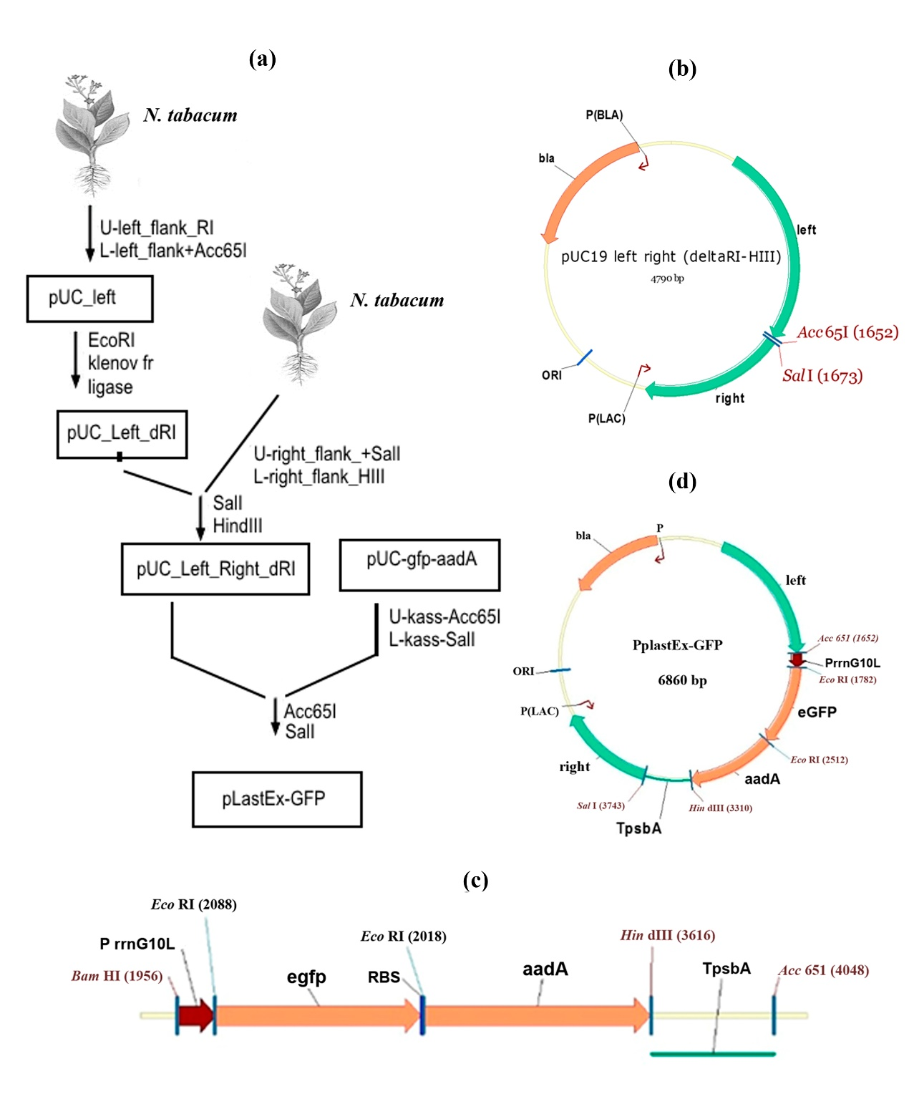
Fig. S1. Design of the expression vector pPlastEx-GFP.
a – general scheme of construction; b – intermediate plasmid pUC19_left_right-(deltaRI-HIII); c – expression cassette, where PrrnG10L is the promoter of the rRNA operon (Prrn), fused with the leader sequence of gene 10 of phage T7 (G10L), egfp is the coding sequence of the green fluorescent protein gene, RBS is the ribosome binding site, aadA is the coding sequence of the spectinomycin resistance gene, TpsbA is the terminator of the psbA gene encoding the D1 protein of photosystem II; d – final plasmid (vector) pPlastEx-GFP, used for transformation of the plastid genome.

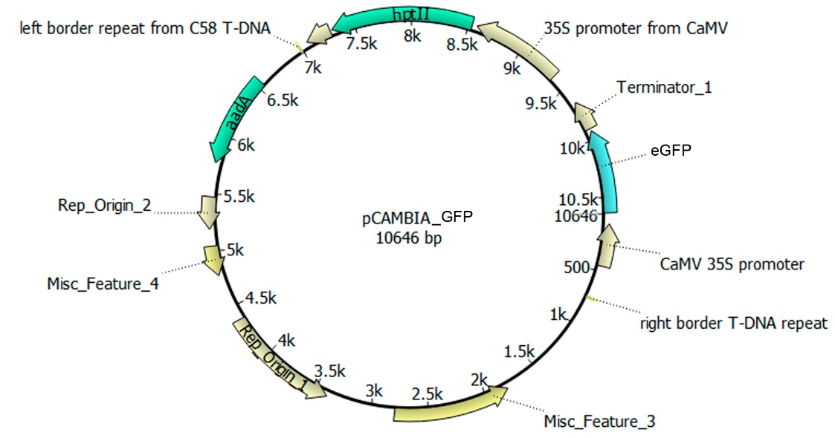
Fig. S2. Vector for obtaining nuclear transformants expressing a reporter gene egfp.

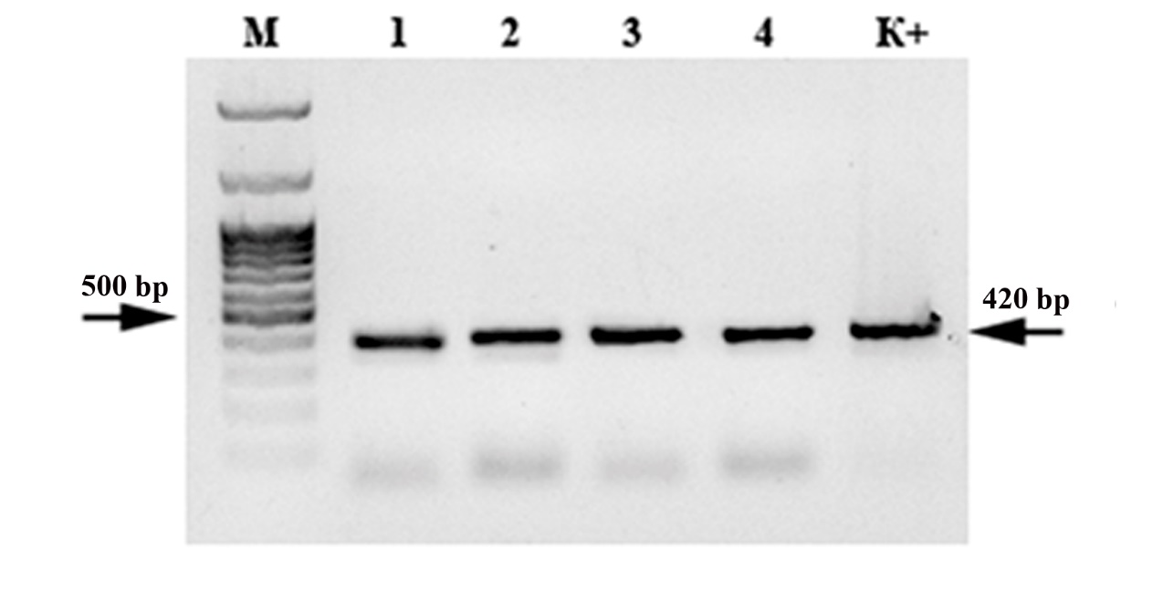
Fig. S3. Gel electrophoresis of amplification products in 1% agarose gel (using 4 samples as an example) confirming the presence of the egfp gene in the genome of nuclear tobacco transformants T₀.

Table S1. Primers structure for amplification of homology flanks to the insertion site.
Gene | Primer | Primer sequences
Homology flank left | Forward | 5' GGTGAATTCGTTCCCGGGC 3'
 | Reverse | 5' GCCGGTACCGCTGGGCCATCCTGGACTTG 3'
Homology flank right | Forward | 5' CCCGTCGACAGCTGCGCCAGGGAAAAGAA 3'
 | Reverse | 5' CATAAAGCTTTGTATCGGCTAAGTTCA 3'

Table S2. Primers structure for amplification of expression cassette gfp-aadA.
Gene | Primer | Primer sequences
gfp-aadA | Forward | 5′ AGCGGTACCCGCCGTCGTTCAATGAGAAT 3′
 | Reverse | 5′ GCTGTCGACCCAAGATCCAAGATAAAGTA 3′

Table S3. Primers structure for gfp and aadA genes detection in genome of nuclear transformants and plastid genome of transplastomic plants by PCR.
Gene | Primer | Primer sequences | Fragment length, b.p.
Nuclear transformants
egfp | Forward | 5′-TTG TGC CCC AGG ATG TTG CC-3′ | 420
 | Reverse | 5′-GGT GAG CAA GGG CGA GGA GC-3′
Transplastomic plants
egfp | Forward | 5′-GAGGAGCTGTTCACCGGG-3′ | 702
 | Reverse | 5′-CTTGTACAGCTCGTCCATGC-3′
aadA | Forward | 5′-ATGGCAGAAGCGGTGATCG-3′ | 290
 | Reverse | 5′-GCTCGAAGATACCTGCAAGAATGTC-3′

Table S4. Primers and probes for multiplex qRT-PCR.
Gene | Primer | Primer sequences
egfp | Forward | 5′-TCCATGCCGTGAGTGATCCC-3′
 | Reverse | 5′-GTCCGCCCTGAGCAAAGACC-3′
 | Probe | 5′-FAM CAACGAGAAGCGCGATCACATG-BHQ1-3′
aadA | Forward | 5′-GACATTGATCTGGCTATCTTGCTGA-3′
 | Reverse | 5′-GAGTTCCATAGCGTTAAGGTTTCATT-3′
 | Probe | 5′-R6G TAGCGCCTCAAATAGATCCTGTTCA-BHQ2-3′
ycf2 | Forward | 5′-CCCACACGAAGTTTGTGAATAAGTG-3′
 | Reverse | 5′-GATTGAACAACCGGGAGCAA-3′
 | Probe | 5′-ROX TGTCTGATAATGAGCAAGGAATATCCG-BHQ2-3′

